**Project Design Phase - II**

**Technology stack (Architecture & Stack)**

|  |  |
| --- | --- |
| Date | 19 September 2022 |
| Team ID | PNT2022TMID16408 |
| Project Name | University Admit Eligibility Predictor |
| Maximum Marks | 4 Marks |

**Techn**

**ical**

**Architec**

**ture**

**:**

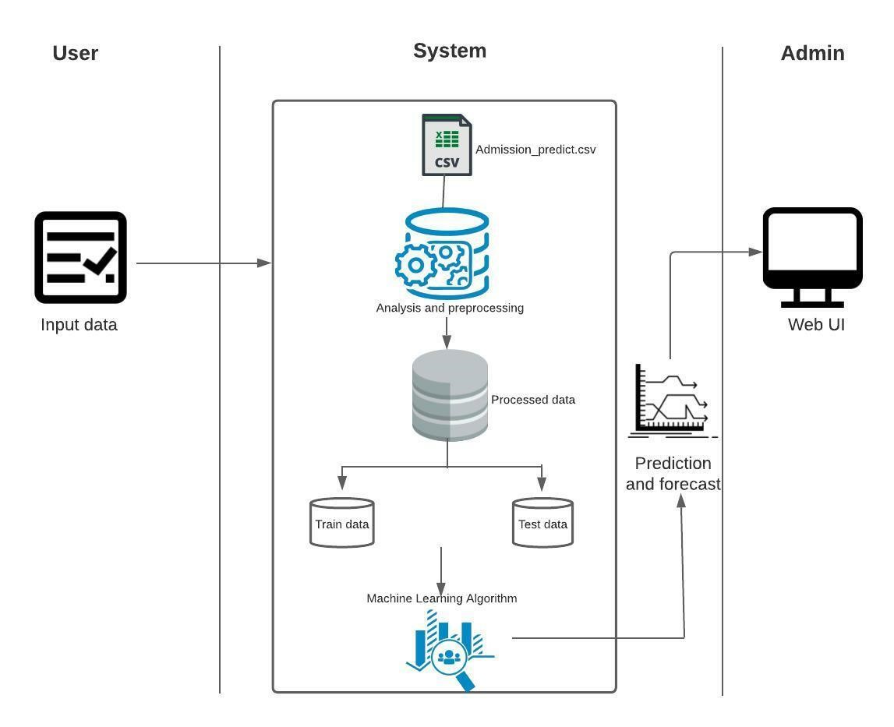

**Table-1: Components and Technologies:**

|  |  |  |  |
| --- | --- | --- | --- |
| **S.No** | **Component** | **Description** | **Technology** |
| 1. | User Interface | The user interacts with the application through a Web UI | HTML, CSS, Python, Flask |
| 2. | Application Logic-1 | Logic for collecting the input from the user | Python |
| 3. | Application Logic-2 | Integrating Machine Learning model with our application | Python |
| 4. | Database | Numeric data | MySQL |
| 5. | File Storage | To store files such as prediction report | Local Filesystem |
| 10. | Machine Learning Model | Predictive modelling is a mathematical process used to predict future events or outcomes by analysing patterns in a given set of input data. | Predictive Modelling |
| 11. | Infrastructure (Server) | Application Deployment on Local  System  Local Server Configuration: Built-in  Flask web server | Flask, Web server |

**Table-2: Application Characteristics:**

|  |  |  |  |
| --- | --- | --- | --- |
| **S.No** | **Characteristics** | **Description** | **Technology** |
| 1. | Open-Source Frameworks | Flask | Micro web framework with python |
| 2. | Security  Implementations | Http authentication, Session based authentication | Flask security |
| 3. | Scalable  Architecture | Size is everything, and Flask’s status as a microframework means  that you can use it to grow a tech project such as a web app incredibly quickly. Its simplicity of use and few dependencies enable it to run smoothly even as it scales up and up. | Flask |
| 4. | Availability | Higher compatibility with latest technologies and allows customization | Flask |
| 5. | Performance | Integrated support for unit testing.   * RESTful request dispatching. * Uses Jinja templating. * Support for secure cookies | Flask |